39

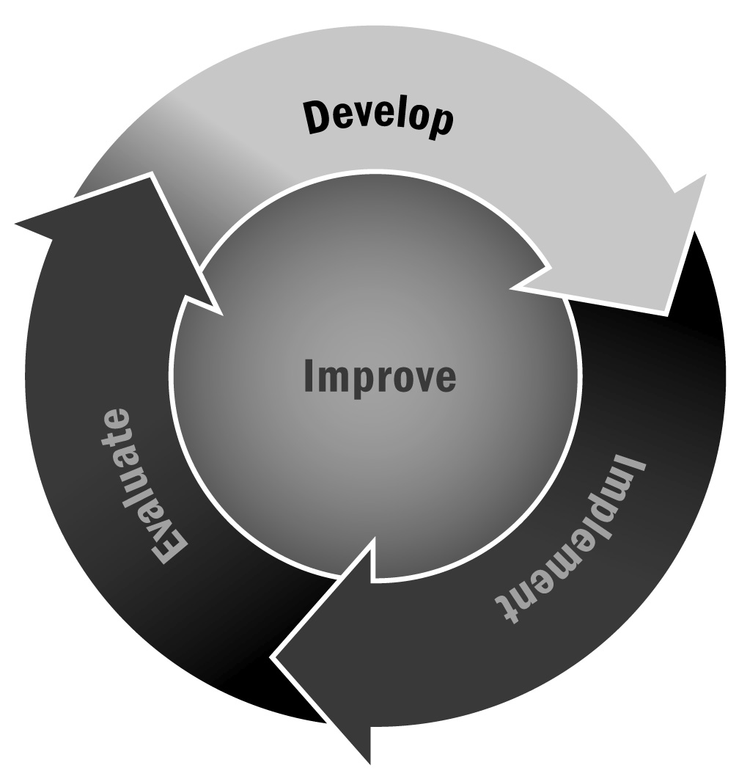
Developing a Theory of Change
In Chapter 2, you learned that a theory of change can be an important way to graphically depict your program’s overall vision and goals and to illustrate how you will achieve them. A theory of change is an important communication tool as well, and it helps you ensure that your program activities are targeted toward achieving your goals.
Directions: Developing a theory of change can be a complex process, and there are many great resources out there to help you. Rather than tell you exactly how to create one, this tool will provide you with important definitions and resources so you can explore the topic yourself in more depth.

What Is a Theory of Change (TOC)?
A TOC is a visual representation of what your program is going to do to achieve its larger vision or goals. Simply put, it shows the change you are going to make and how that change is going to happen. A good TOC can help guide your programming decisions and serve as a communication tool for funders and other key stakeholders.

How Is a TOC Different From a Logic Model?
Many people use the two terms interchangeably, but they are actually two different and separate documents. A TOC shows a causal link between strategies and outcomes. A logic model goes into a bit more detail about your activities, your inputs, and your outcomes but doesn’t necessarily show how one affects another.

Is There a Specific Format I Should Use?
No. There are different kinds of theories of change and different ways of graphically representing your program. Some are artistic, using images and pictures. Others are linear, using sets of boxes connected by arrows. The important thing is to show your intended goals and the strategies you will use to accomplish them. We can’t tell you what format will work best for your program. It is best to look at a variety of examples to get ideas. Here are a few different ones to give you a sense of the range and styles organizations use:
- The Wallace Foundation’s TOC for their philanthropy work: http://www.wallacefoundation.org/learn-about-wallace/approach-and-strategy/Pages/our-approach-to-philanthropy.aspx
- The Forum for Youth Investment’s TOC for their Ready by 21 initiative: http://www.readyby21.org/what-ready-21/our-theory-change
- Dudley Street Neighborhood Initiative’s TOC: http://www.dsni.org/youth-opportunities-and-development-0

What Are Some of the Key Steps in Developing a TOC?
- Determining the purpose of a TOC – Before you start developing your TOC, you’ll have to spend a little time thinking about how you want to use it. Is it for evaluation purposes? To communicate your program model to funders, legislators, and board members? As a guide for program leadership and staff? Determining your purpose will help you decide how to proceed with the next several steps.
- Gathering stakeholder input – It is important to involve a variety of key stakeholders in your TOC process. You may gather input from them individually or in small groups, or you may involve them in a large group TOC process.
- Identifying assumptions – Every afterschool and expanded learning program is built on a set of assumptions relating to how and why it is operating. Even before you develop your goals, it is a good idea to identify the assumptions that are built into your program. This might include things like “being in afterschool programming is better for the young people of our school than going home and being alone after school” or “youth in our school who are falling behind won’t be able to catch up without additional academic support.”
- Developing goals – Having clearly articulated goals is essential when developing a TOC. You have done this as part of your goal-setting process by using Tool 37. You’ll want to revisit these as you start working on your TOC.
- Outcome mapping (sometimes called backwards mapping) – Developing an outcome map is often part of developing a TOC. This step involves brainstorming a list of outcomes (which can be short and long term) and linking them to specific strategies or program elements.
- Creating a narrative to accompany your TOC – Ideally, you’ll want some kind of narrative to accompany your TOC in order to explain what people are seeing. You want your TOC to be understandable without a narrative, of course, but a paragraph explaining exactly what you hope will happen with your program can be useful when distributing the TOC to outside audiences.

Where Can I Learn More?
- You Can Get There From Here: Using a Theory of Change Approach to Plan Urban Education Reform
James P. Connell and Adena M. Klem of the Institute for Research and Reform in Education (2000), Journal of Educational and Psychological Consultation, 11(1), 93–120. This article can be accessed online at http://www.irre.org/sites/default/files/publication_pdfs/jepc_0.pdf. It provides a definition of a TOC and explains how it is used, what features it should contain, and other relevant information.
- Theory of Change: A Practical Tool for Action, Results and Learning
This document, prepared for the Annie E. Casey Foundation in 2004 by Organizational Research Services, contains a wealth of information about how to develop a theory of change in partnership with your community and contains several specific exercises to help you with the process. Learn more by visiting http://www.aecf.org/upload/publicationfiles/cc2977k440.pdf.
- Center for Theory of Change
The Center for Theory of Change is a nonprofit organization established to promote quality standards and recommendations for the development and implementation of a theory of change, with a particular focus on its use and application in the areas of international development, sustainability, education, human rights, and social change. Their website contains a variety of information about defining and building a TOC, which you can access at http://www.theoryofchange.org.

